Think Again

STORIES OF PEOPLE WITH DISABILITY AND THEIR SUPPORTERS WORKING CREATIVELY TO BREAK DOWN BARRIERS

The mission of Community Resource Unit (CRU) is to work for full and meaningful lives for people living with disability. To do this we work with people living with disability, their families, allies in human services and the community to build a movement for change.
For more than 35 years, we have resourced people to lead their own change. We provide information, analysis and inspiration, link people with each other and invest in grass roots leadership development.
We acknowledge the traditional owners of all the lands on which this booklet was produced and recognise this land always was and always will be Aboriginal and Torres Strait Islander land.

We recognise the significant contributions of First Nations people, their continuing connection to land, water and community. We seek relationships based on recognition, reconciliation and justice and pay our respects to elders past and present.

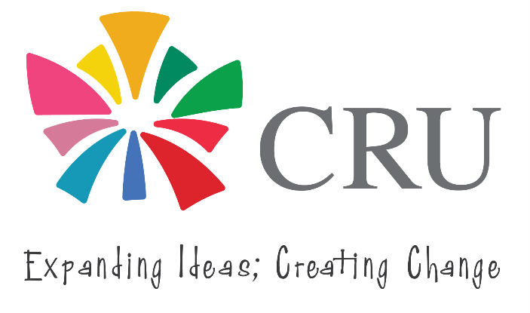
Community Resource Unit Ltd
ABN: 16 143 460 250 ACN: 617 860 009
Level 2/43 Peel Street, PO Box 3722,
South Brisbane QLD 4101
Phone: 07 3844 2211 Email: cru@cru.org.au
Website: www.cru.org.au

Thank You
Thank you to all those who generously shared their stories, to help others imagine the possibilities.
We acknowledge the tremendous leadership of people with disability and their families, who have pushed the boundaries for us to learn.
We want to acknowledge the contribution of the many people who helped bring this booklet into being. Firstly, the members of the Steering Group (2020 – 2024) – Leanne Burke, Benita Bierzynski, Bobby Noone, Maureen Fordyce, Neil Barringham, Morrie O’Connor and Toni Sumner, who joined Danielle Mason and Margaret Rodgers from CRU.
We thank them for taking up the challenge to try to make a difference in the lives of people with disability and their willingness to struggle with these complex questions over time.
We want to acknowledge the important work of Bridget Patchell who worked with the steering group to document and record examples of innovation during 2021. And thirdly, we are indebted to the people who have written or shared their stories and their reflections with us.
Please note that in some of the articles people’s names and circumstances have been changed

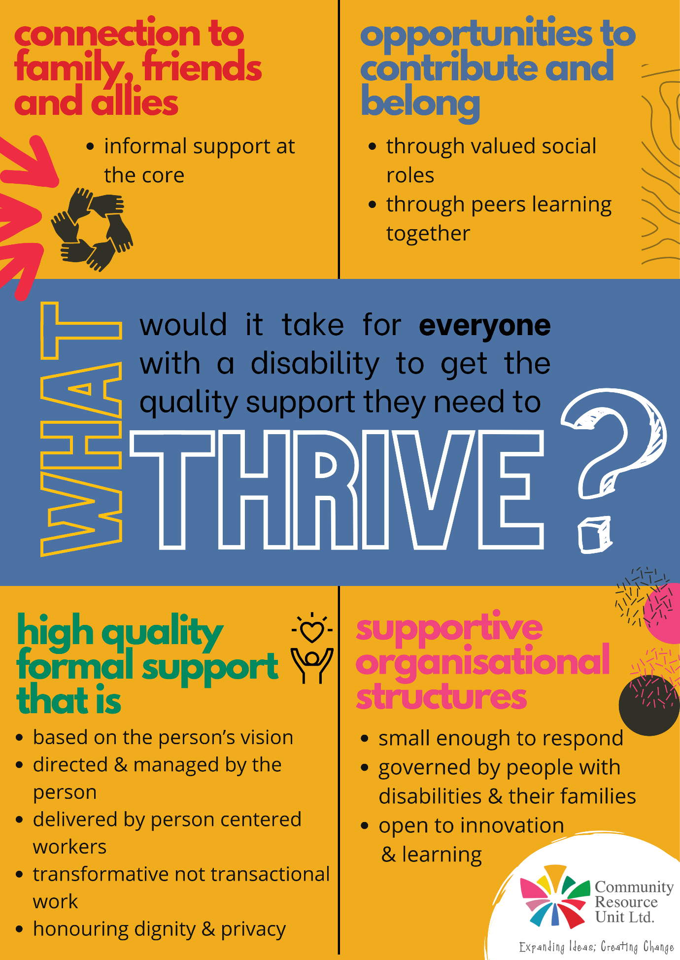

Foreword
The introduction of the National Disability Insurance Scheme (NDIS) in Australia has created a massive change to the way people with disability are supported in the community. This change has been beneficial to many people, who are getting levels of support they never would have before.
However, some people with disability have struggled to engage with the system for various reasons.
- Some people haven’t been able to navigate the access and planning process and so are missing out on support altogether.
- Some people have found that the supports they have relied on over the years are no longer there, and the NDIS funding model has meant some services are no longer viable.
- Some have found that the NDIS ‘market’ is unable to provide them with services in the way they want, and they find themselves pressured into accepting options that don’t match the way they want to live their lives.
Many of those who struggle to engage with the NDIS are those people with disability who experience multiple life barriers, such as young people especially those leaving the care of the State, LGBTQI+ people, people with complex mental health conditions, people from CALD backgrounds and Aboriginal and Torres Strait Islander people. The complexity and risks often increase when people need to interact with multiple services and systems.
In 2020, the “New Ways” Steering Group was convened by CRU to find ways to help people with disabilities and their families get the most out of the NDIS and other systems so that they can live fulfilling lives as members of the wider community. We asked ourselves ‘what would it take for everyone with a disability to get the quality support they need to thrive?”
Harnessing existing knowledge and experience is an important foundation to thinking creatively about new possibilities. It was anticipated that not everything that is called ‘new’ is actually new and that some of the ‘new’ possibilities may be similar to previously successful initiatives.
The Queensland disability sector has a strong track record in dealing with such challenges over many years with people with disability, their family and other allies working together to solve problems and to build a community that is more inclusive of people with disability.
The voluntary steering group decided that with limited time and resources what they could do would be to find and highlight good examples and capture our wisdom, experience and history. They knew that gathering people together to share this information would be important in highlighting what is possible, creating change and drawing attention to the gaps. They also hosted a forum where guest presenters experiencing multiple life barriers and the people who support them shared their stories.
Reviewing books and reports and drawing on interviews with experienced people, four main themes consistently arose around the question “what would it take for everyone with a disability to get the quality support they need to thrive?” These four themes working together and in their right place can help to build a good life.

These themes are:
1. The primacy of informal support
2. Contribution and belonging
3. High quality formal support
4. The impact of organisational structure

This booklet is designed to share stories and reflections that will bring those four essential themes to life. It invites us to THINK AGAIN about how we provide support that helps people thrive. The stories introduce us to people with disability who encounter additional barriers and invites us to THINK AGAIN about who they are and the contribution they make. It invites us to THINK AGAIN about our assumptions. It does not contain easy steps or straightforward answers, but it does contain examples that show what can be possible for people with disability, including those who experience multiple challenges and barriers.
Margaret Rodgers I CEO
Community Resource Unit

Contents
Table of Contents
Thank You 3
Foreword 5
Contents 7
1 The Primacy of Informal Support 8
Assisting Communities to be Welcoming 9
Circles of Support 14
Citizen Advocacy Framework 16
A Citizen Advocacy Story 17
2 Contribution and Belonging 20
The Right Personal Valued Roles for Me - Uncle Willie’s story 21
Jo’s Story 24
Power of Peer support 27
A Story of Peer Connection - Mum’s Group 27
Men’s Group 31
3 High Quality Formal Support 32
The Work of AMPARO 33
Finding a Path to Culturally Appropriate Service Delivery 37
Transformative rather than Transactional Work 40
The ARROS Service Model 41
4 Impact of Organisational Structure 45
Size matters 45
User and Family Governed Organisations 46
Lessons from Homes West 47
Conclusion 51
Back Cover 52

“Creativity involves breaking out of established patterns in order to look at things in a different way.” - Edward de Bono

1 The Primacy of Informal Support
There is growing evidence that as humans, our freely given relationships – our friends, allies and family – are our greatest safeguards in life.
These informal, unpaid, or ‘natural’ supports help us to feel a greater sense of belonging, safety, intimacy, and spontaneity. Having others in our lives that deeply enjoy our company and care about our welfare is invaluable.
Many people with disability are lonely. Many have been disconnected from their family and their communities. Many people spend their days only with people who are paid to be with them. This dependence on funded support means the person is completely exposed to the vagaries of service systems and their ever-changing funding, policies, agendas and identities.
The explorations of the “New Ways” steering group reinforced that informal support is not just a nice addition when everything else is in place, but that people have better lives when this part of their life is prioritised and is strong and thriving.
The articles that follow give examples of how relationships can be intentionally developed or rebuilt for and with people who are isolated. They show how quite small amounts of funded supports can be used to harness informal supports.
When ordinary people are asked and supported they can and do step forward and stand with marginalised people. The asking and the supporting needs to be done thoughtfully.
“For most of us, life’s richest meanings spring from our personal relationships and connections. That’s why the desire to belong is a throbbing urge that won’t be stilled until our hearts find safe lodgings.”
Hugh Mackay, The Art of Belonging (2014)

In this article Neil describes his work, building community with people with psycho-social disabilities. This article was originally published in ‘Like a Sweet Cup of Tea’, and was dedicated to the memory of Shula Rice.

Assisting Communities to be Welcoming
Neil Barringham is a community worker who enjoys his rainforest backyard and neighbourhood. Neil has worked with others in his home and neighbourhood to facilitate inclusion and community supports. As an inclusion worker with “A Place to Belong”, Neil worked with allies over many years to build community-based supports and opportunities for participation with people who lived with mental health challenges and a desire to belong. Neil has post graduate qualifications in community development and social work.
When I talk to others about assisting communities to be more welcoming and inclusive, I firstly think about how I go about this in my own neighbourhood. It is important to me that the work I do in my professional life is in parallel with what I practice in my own neighbourhood. In the context of each, I try to base my actions on three important things: the importance of simplicity; the importance of spirituality; and the importance of solidarity. I define these in the following ways. Simplicity is about being willing to move down the ladder, to slow down, to create more open spaces rather than filling up spaces, and divulging power rather than clutching at power. Spirituality is about depth, congruence, openness and generosity, and finding ways to nurture hopes for a more peaceful and loving world. Solidarity with others in my neighbourhood is about working with whomever I can – in whatever ways we can – towards a more peaceful and just world in our ‘little patch’.
I enter my professional involvement from a personal base of working towards simplicity, spirituality, and solidarity in my own neighbourhood. I suggest that if any of us wishes to facilitate communities to be more welcoming, then we need to begin by acting in the context of our own lives, whether in our neighbourhood, our workplace, or a club or group to which we belong. Finding one person who is marginalised in any of these settings might involve spending informal time with that person, doing ordinary or simple things together, or listening to that person’s story or sharing our own. We need to remember that the foundation of all community development is an attentive, respectful conversation between two people. I also believe that it is important for us to constantly reflect on our own lives and on the lives of those who are marginalised in our own communities. We need pointers: stories and insights that inform our work and our thinking.
Stories and insights
One recent example for me came from a spirited woman named Shula. I met Shula through my work at A Place To Belong. She lived in another area from my own home neighbourhood. Shula was a stylish, gifted, artistic, and intelligent woman in her late twenties. She inspired others with her story and her reflections on life yet she still struggled and suffered. Shula experienced the ravages of a depression so profound that she was hospitalised twenty-five times in five years. She felt she had experienced a living death. “One way I can describe it”, she wrote, “was that it felt like there was a void inside me – nothingness, where the person I was, used to be. It was as though a violent storm had raged through every room, every corridor of my being, sparing nothing. In my eyes, it was a cruel world and I deserved all the shit I got.” She said that pain, grief, shame and loneliness were her companions and that they were the only certainties in a world she had lost control over; they were the only feelings that told her she was alive. Shula’s words, articulated so expressively, give a picture of the disabling effects of mental illness with the pain of disconnectedness from self and from others.
While the words of Shula and others often guide my work, I have also come to understand that when we are trying to connect a marginalised person more strongly to others in their community, some important factors need to be kept in mind. Firstly, because each of us is unique, a sense of belonging will differ for each of us; we might gain a sense of belonging through different experiences. For example, some might feel that they belong through a sense of making a contribution; others might feel that they belong through having just one person in their neighbourhood catch up with them on a regular basis. Secondly, gaining a sense of belonging is a deeply personal process. For community activists, the work of developing more inclusive communities is far more than social mapping or social management. Belonging and friendship are of the heart and spirit; they are cultural processes. Thirdly, it is important to recognise that having a sense of belonging is a challenge for everyone. I come to my work with a deep sense that I often struggle to relate to others in my neighbourhood and community; friendship is at times a lonely and complicated process for me. In the modern world, a sense of belonging is not only a disability issue; it is also a societal issue. We are all broken and all unique. In many ways we are all able and disabled.

Working one-by-one, each of us can assist a community to have a spirit of welcoming. Any one of us can be community builders, community assisters, or community connectors. We might be paid or unpaid, a carer, a family member, or friend. While we cannot manufacture inclusive communities, we can search for those spaces, places and people where inclusion and connection might occur. We can ask, invite, link and create opportunities. We can affirm, encourage and sometimes simply just wait for the right moment. Neighbourhood streets might look empty, people may look busy and preoccupied, front-doors might appear closed, but there will be open spaces somewhere and a community connector will be someone who believes that there is energy there in spite of appearances.
One-by-one
A good example of this simple one-by-one way of connecting people can be found in the following illustration. A support worker was concerned about helping the man he was working with. He wanted to establish links with the man’s neighbours when the man moved from hospital to his new residence in a block of flats. Together, they considered how he could meet his neighbours in a simple and natural way. They decided not to go door-to- door, introducing themselves. After noticing a bench at the front of the flats, which was beside the letterboxes, the worker suggested that they try sitting on the bench for a while after the mail was delivered. Sure enough, people came out to collect their mail and within days of trying this plan, the man and his worker met a number of his neighbours, some of whom became reasonably close friends with the man. The worker didn’t just see a bench; he saw an opportunity for connection.
Fundamental to my work is getting alongside a person who indicates a desire for a greater connectedness, and to understand something of that person’s situation. I begin by finding one person in the community who might be able to respond to the person’s yearning to belong. For example, a man who had lived in a large institution for many years came to a suburb where he had never lived. He knew no one. His only friends were a couple of people he had known in hospital and who now lived a long way away. The man’s mental health is extremely fragile and he often needs to stay at the local mental health clinic. I helped him meet a woman who has now kept in touch with him for four years. They go to art shows, for walks and enjoy coffee together. They talk regularly on the phone. He describes their friendship as being “like a sweet cup of tea”.
Learning from mistakes

Like most people, I learn from my mistakes. For instance, I learnt a strong lesson from the following experience. I was working with a man that I will call Bill. Bill lived in a psychiatric institution for more than twenty years and I met him six years ago when he expressed interest in attending some story-sharing groups and informal workshops being run by our small organisation. He needed permission for leave from his doctors, and some protocols were agreed upon before we could welcome him to the group. We could see that Bill needed someone who would stand beside him and become an ally. We thought that a man called Gary, who was already coming to some of the activities, would fit that role, and he agreed. Over the following three years Gary kept in touch with Bill. He visited him regularly, spent many hours talking with him and made arrangements with health authorities for Bill’s leave as well as arranging transport to group activities.

At the end of the three years, Gary’s own circumstances changed and he was unable to commit to his role as Bill’s ally and we wanted to find other ways of supporting Bill. I talked to a few people who knew Bill and we searched for ideas. One day I was having coffee with a man named Joe who knew and respected Bill. He had an idea that we both became excited about. Joe plays for a football club and he had the idea of inviting Bill to attend games and to help carry water to players. We thought Bill might like that role: he would be with other males, outdoors in a sporting context, and would be making a contribution in a genuine way. Bill liked the idea and so did the hospital team that provided health services to Bill.
Then I made my mistake. It was decided that Joe would approach the president of the club to check out the idea with him. Joe knew the president and felt there wouldn’t be a problem. However, the president baulked and said he would need to go to the management committee. As soon as this happened, I knew I had erred. As many of us know, committees are places where ideas are lured and then slowly strangled. I had forgotten some earlier learning: if you go to the leaders of an organisation in a one-off fashion, you will usually be talking with people who are struggling to manage the complexities of that organisation, and who will therefore probably not be open to ideas about including a person who has support needs or who could be highly stigmatised. I had learnt that it was generally more effective to firstly work with someone who is supportive, and who can generate an informal welcome before seeking formal approval – a general club member. Sure enough, the committee said, “No. Not viable.”
I wish now that we had simply taken Bill to a few football games, let him hang around Joe and his team mates, gradually getting to know them, and meeting the coach informally. Within the context of established relationships, we could then have looked for an opportunity for Bill to be a water-bottle carrier on a day when someone was needed. Letting team members get to know Bill on a first-hand basis might have been a more effective approach.
Finding allies
Finding allies for a marginalised person remains one of the most effective ways of connecting someone to a group or community. People who struggle with mental health issues are often overwhelmed by the large mental health system that they encounter. In contrast, community connections are small-scale and intimate. Although simplicity is at the heart of community connections, each person who is involved in community-connecting actions needs encouragement. The following are some specific ways in which they can be encouraged:
- Recognising that the first step towards including someone in the community is through attentive, responsive conversation;
- Affirming and honouring the involvement of ‘amateurs’: those people in our communities who are grounded, practical, and can offer friendship;
- Encouraging these grounded people to become an expert – not so much an expert about a person’s diagnosis, medications, mental health history or the science of psychiatry – but an expert in understanding the life experiences, hopes and struggles of the person that they stand beside;
- Encouraging people to focus on simple and ordinary things – the beauty, life and divinity that can be found in the everyday, the ordinary and the obscure;
- Recognising that recovery is often more about a person marshalling inner resources and working in partnership with others than it is about ‘getting better’ or ‘being cured’; and
- Trying to find moments of openness. Community connectors can identify and find moments of openness that can occur at times of crisis, celebration, change or chance. The aim is not to push doors open when people want them closed but to work with moments of openness when they occur. (The work of Dave Andrews describes this concept well.)
Conclusion
The importance of using a simple approach should not obscure the critical nature of community building efforts: they are about the threads of love and care that build our interconnectedness, our sense of identity, our hopes and dreams. They are indeed the threads that connect us to our own selves. They are not to be romanticised or seen as utopian. The threads of community that we might be working with are not the answers to our suffering and ailments.
Community will not cure affliction or disability, but community does give us an enriched context within which we can live out our ailments, our struggles, our suffering and our joys. Jack Yates expresses it this way: “Community is the only uncontrolled space, the only place you can sing together, and the only place you can die together, the only place you can never abolish suffering, and the only place you can never abolish joy.”
“The most precious resource we have for coping with life in an unstable, discontinuous and revolutionary world is not information, but each other.” - Hugh Mackay, Turning Point: Australians Choosing Their Future (1999)



Circles of Support
Circles of Support are semi-formal structures designed to harness the goodwill of supporters and help them to work together on behalf of a person with disability. This is not a team meeting of paid staff but a group of people who come together because they care about the person. A Circle can create an opportunity for a person with disability to invite others to join them as allies. Circle members usually meet regularly and can provide fresh ideas and connections. They can become people to plan with, help instigate these plans, and support people in their decision making.
Purpose: One of the most important challenges is being clear on the purpose. If this is done with the person before the invitations are sent, there is a better chance of a good match between the circle members and the purpose. If there is an expectation that circle members will drop in spontaneously or help to fill a social vacuum, then inviting people who are busy and live some distance away is unlikely to be a satisfying match for either party. Some circles have a short-term role to achieve a particular task and others have a long-term, safeguarding focus.
Facilitation: Having a facilitator for the support circle helps to introduce a semi-formal structure to a group and keep the focus on the needs of the person with a disability. Without someone to assist and focus the conversation, it is likely that the group will remain at a social, informal level, which, though very pleasant, is not usually the best way for a person with a disability to communicate their issues, concerns, hopes or dreams.
Ground Rules: The group will need to decide when, where and how often they meet and for how long. With the best of intentions, support circle conversations can easily move into areas that the person is not ready to discuss. Working out in advance what the person should do if the circle gets too personal is also time well spent. Making notes of the meeting will also help to keep people informed and involved and become a record of the changes that are often very subtle.
Planning: Wherever a group starts, they will need to work out what is right for that group of people at that time. Setting time aside to plan for the person’s future can also help the group to identify their role in that process. Formal support can then fit into their overall plan and vision for the person, rather than the more common trend of formal service provision taking primary place and the person and the family and friends having to fit in.
Roles: Initially, it may be unclear and at times frustrating, as people work out their roles and the group finds a pace and style that is comfortable for the person at the centre of the group. People often join a support circle feeling quite mystified as to what they can do – they may need some information and support to help them extend and deepen their relationship with the person.
Who to invite: Sometimes, people who work or have worked in the disability sector are invited to join a support circle. Their experience can be useful if they can contribute without overwhelming the voice of others in the support circle, who do not have that experience. Circle membership requires them to be biased. Their loyalties may feel divided as they take part in conversations about one person, when they are acutely aware of the needs of many others. Generally, we would not invite people who are currently employed for or by the person into the support circle. This is an attempt to separate the formal support from the informal support. Most people we would invite don’t know much or anything about the disability sector and may not even know another person with a disability. Most of the time, this can be a great asset. What they do know is that life for people with disabilities often looks very different to their own lives or the lives of their own family members: The usual doors are not opening; the usual plans and dreams are not being explored.
The person is central: Sometimes it is difficult to discuss delicate issues when the person is present, but by taking the time and being respectful, it is not only possible, but it is important that the person is given every opportunity to be there. This can be a positive experience for the person with the disability as people develop trust in their circle and the confidence to articulate their hopes and dreams. Support circle members may also share from their own life experiences, which can be more helpful to the person as an example of what a good and ordinary life can look like, rather than what they might see in movies and television series.
Circles of support are not a cheap alternative to replace services and support circle members are not unpaid staff members. Support circles are not support groups for people with a disability or support groups for parents of people with a disability. They are neither strategic think-tanks, nor should they be set up by a service provider who thinks a family needs it. Instead, support circles are a very powerful strategy for inviting ordinary people to walk alongside, focus on and make a commitment to people with a disability and their families, as they dream, plan and achieve the lives that they want.

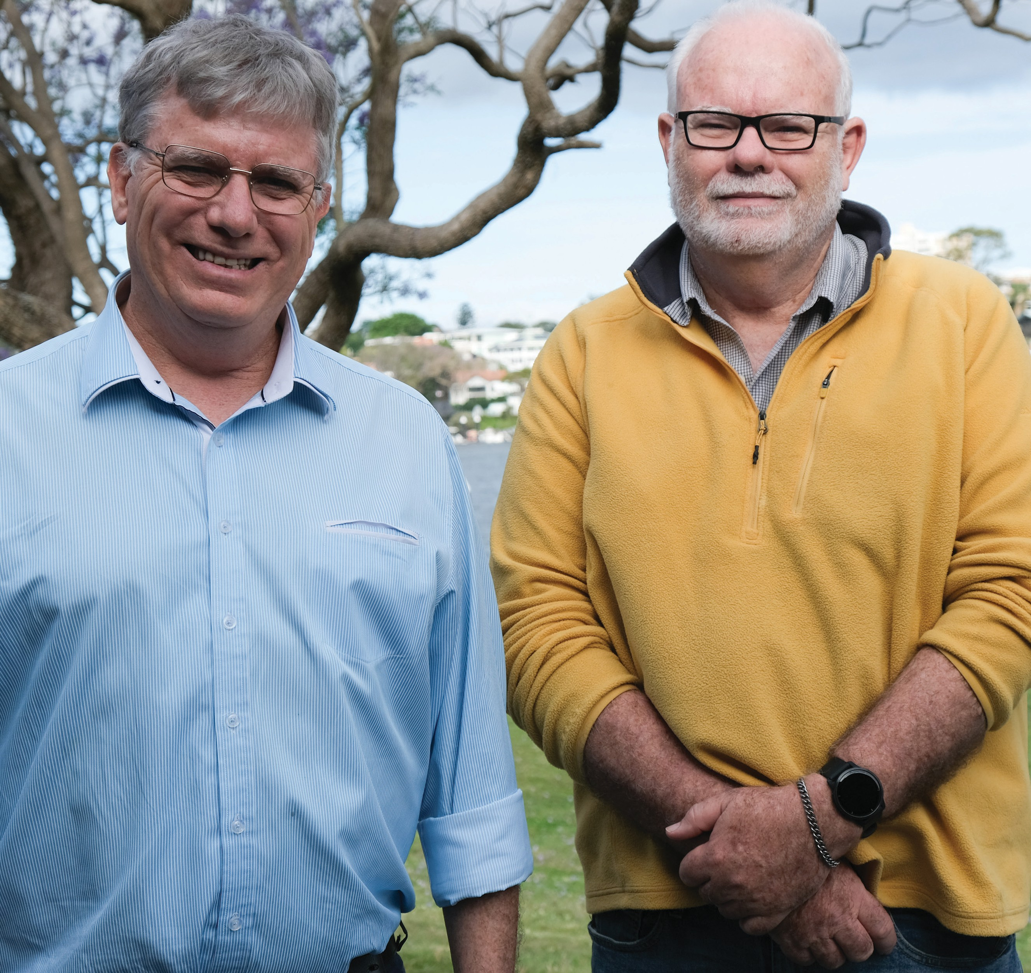
Ewan and Peter from Capricorn Citizen Advocacy

Citizen Advocacy Framework
Citizen Advocacy involves the development of an intentional relationship between a person with disability and an unpaid citizen who commits to providing long-term advocacy to the person. Citizen Advocacy believes that vulnerable people with a disability, who are without family or friends, are especially in need of at least one loyal long-term ally who is single mindedly committed to them. The advocates are asked to be loyal and accountable in promoting, protecting, and defending the person’s rights, and to help them be treated as a respected and valued member of the community.
In this article Peter describes his relationship with Mitch and how this has evolved over time to be a rich experience for them both.

A Citizen Advocacy Story
The adventures of Mitchell and Pete
Peter Edman is a Citizen Advocate, a teacher with over 25 years’ experience (including as a support teacher - inclusive education). He now runs his own education consulting and tutoring business. Peter has a long history of supporting people, from friends to complete strangers. Becoming an advocate has been a logical extension of Peter’s journey and is one achievement he is particularly very proud of.
Capricorn Citizen Advocacy is a Rockhampton-based disability advocacy program. It assists those with cognitive or intellectual disabilities who may rely heavily on others to support them every day, especially if they are segregated from the general community and are isolated.
“We met in prison.” That has become the stock in-joke Mitchell and I use when asked where we go to know each other. It’s true, but with a difference. As Mitchell says, I’ve been to jail more times than he has, it’s just that my stays weren’t as long.
When I heard Mitchell’s story and how he had been chosen by the prison management as a prospective candidate for a citizen advocacy program in Rockhampton, I put my hand up to be involved. As a result of my friendship with the coordinator, I had some idea of what was required. I later became a committee member of Capricorn Citizen Advocacy.
From my first visit, Mitchell and I clicked, talking about mechanics and cars among other things. We’re about the same age so there was a shared understanding of a few issues. Each visit was marked by frequent cups of coffee – always my shout as he couldn’t leave his seat without permission.
Visiting prison was an eye-opener for me, seeing the conditions and the range of people as inmates and their families and supporters. There’s a shared sense of loss and embarrassment at being there. It’s easy to be judgemental but when you don’t know the backstories or what brought them to this point; it’s always better to be accepting and remember that we’re all only a bad decision away from being in similar situations.
Mitchell did not fit the same mould as many other “proteges” (recipients of the advocacy relationship) as he did not have an intellectual disability but rather an acquired brain injury. He is quite articulate with a great sense of humour, although his condition meant that his memory was not as strong.
As part of the process of being an advocate for a long-term prisoner there was a need to get involved and making myself known to different organisations, including government, private and not-for profit. I got to visit places I had no idea about, occasionally stumbling in unannounced in my ignorance. I trod on toes without realising it but later stopped worrying about that when it became clear that sometimes it needed to be done.
Since being paroled, Mitchell has had a few moves with the help of NDIS and different carers. He has managed to purchase a block of land in a small country town where he plans to live permanently. He has continued to pursue his love of mechanics, restoring a couple of Ford XR6s and using the other skills he learnt inside to repair and resell tip shop finds, making some money to finance his plans.
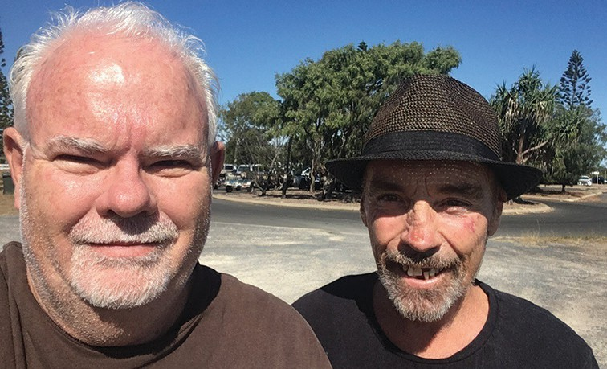
Peter Edman & Mitchell Bell 2020
As a citizen advocate, my role has been to support him with advice and friendship in a “freely- given capacity”. I have provided supporting letters and contacted different groups where it has been needed. Most importantly, Mitchell has been supported to regain his place as an inherently valuable, worthwhile member of society regardless of his disability or past. This is the lesson of social role valorisation which is crucial to everyone, but is not always available without support.
Agencies, whether government, private or not- for-profit, go some ways to provide this support however, for some, more is needed. This is where citizen advocacy comes in. In Mitchell’s case, he had been outside society for seventeen years, and only had a step-daughter as support. Having someone who was only a phone call away, who was prepared to travel to catch up with him, to spend time with him, was vital. This one-on-one relationship was unique, as all citizen advocacy relationships are.
Mitchell’s experiences have given him a view of the world that is different to many, but which matched my own in many ways. We both believe in not taking people for granted and living the commandment to “love your neighbour as yourself”. He is generous with his time and talents and we have shared time working on projects. There is always something to learn working with Mitchell and the relationship is not one-sided at all.
Our relationship has grown and changed. Recently, driving Mitchell from Townsville back to Collinsville, he pointed out that he had stopped thinking of us as being in an advocate- protégé relationship. I agreed. We were now mates, good friends who knew each other’s story and were not afraid to offer advice or feedback on all sorts of topics, usually with a laugh or two. We trust each other implicitly and value each other’s advice and friendship.
Personally, I think that having an advocate has made a significant difference to Mitchell’s life since his release. He has someone who can be there as support when needed, sometimes unexpectedly. On one occasion, dropping in to see him in Gladstone, I pulled up to find police and ambulance at his house. He had been assaulted by a neighbour and was not able to answer questions. As his advocate, I was able to speak on his behalf and answer questions about his health and medication, smoothing over what could have been a difficult situation.
Both of my adult children have met Mitchell. After my son had met him for the first time he said as we were leaving “thanks for looking after dad”, to which Mitchell replied “Oh, he’s all right.” My daughter thinks highly of him and my Rottweiler-cross, normally very wary of men, came straight up to Mitchell for a pat.
Mitchell is currently facing some health challenges and has been grateful for the support from someone outside of carers and family. I’m grateful for the opportunity to know him and be more than his advocate, to be his friend and mate in the best Australian sense. Someone once asked me why I took on this relationship. I was trying to find the right words when my dad, who was present, said “because it’s the right thing to do”.
Advocacy for me is about helping make the world a better place for someone else, without expectation of payment or benefit. I know Mitchell values our friendship. Personally, my match with Mitchell has benefited me in many ways I did not anticipate and which I value immensely. It was definitely the right thing to do and we are both better people for it.

2 Contribution and Belonging
To be present and visible in community is an important first step but to thrive, people also need opportunities to contribute, participate, and belong in their family, schools, workplace, and broader community spaces. The articles below explore how having valued roles and connecting with others for mutual support can be useful strategies to increase connection.
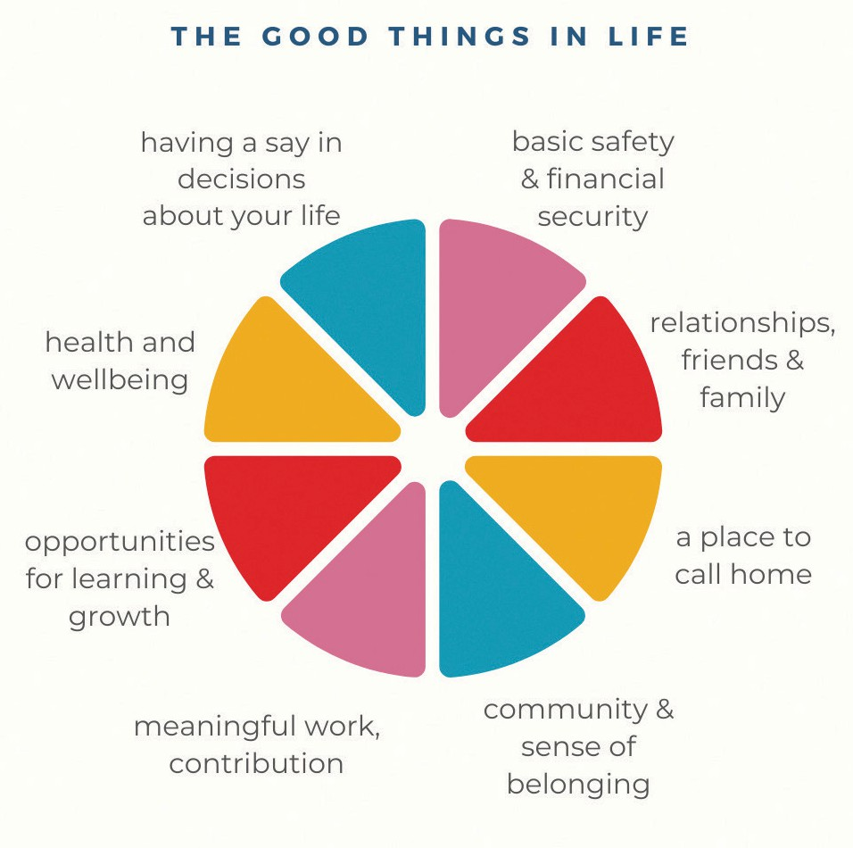
Social Role Valorisation (or ‘SRV’, developed by Wolfensberger 1983) is a theoretical framework that underpins the thinking behind the power of valued roles. This framework helps us understand how prejudices and stereotypes can make it harder for people with disability (and other marginalised people and groups) to access the ‘good things in life.’ SRV provides strategies to avoid reinforcing these ideas and instead support people to be in valued roles that show people in a positive light.

Valued roles can shape every aspect of our lives. They have a strong link to our identities, give us a sense of belonging, open doors to community participation, and help us to build relationships.

As a proud First Nations man, Willie shares his story as a powerful example of how being in valued roles can lead to many doors opening in life.

The Right Personal Valued Roles for Me - Uncle Willie’s Story
Uncle Willie is a proud Kalkadoon man. A respected elder, he helped found the Aboriginal and Torres Strait Islander Disability Network of Queensland. In 2022, he was appointed as an ambassador for International Day of People with Disability.
My name is Wilfred Prince. I am an Aboriginal person with a disability, cerebral palsy. I was born in Cherbourg, an Aboriginal mission in Queensland, on 13th October 1960. During this time, I was like many other Aboriginal people under the control and the care of the government of the day. This was until 1967 when the government held a referendum to include Aboriginal people in the constitution. The majority of the votes were ‘yes’, which meant that I became a citizen of Australia at age 7.
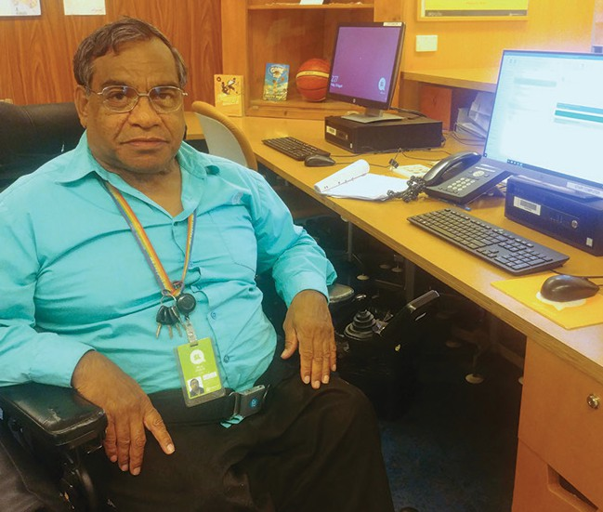
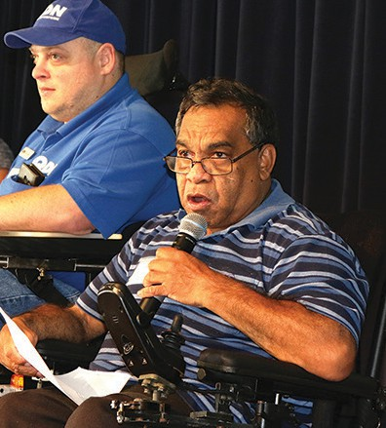
I became ill and was admitted to hospital 16 times before my first birthday. It was on one of these occasions that my visits to the hospital came to the attention of the State Medical Doctor: Why was Willie going to hospital so many times? The State Medical Doctor and the Chief Administrator were deliberating over what to do with me… Then the decision came forth and with a stroke of a pen, I was removed from my family and my culture, and I was transferred to the Royal Children’s Hospital. I was later transferred to an Institution called Xavier Home for Crippled Children. Keeping in mind I was only a young child when I was removed and transferred to an Institution, where I remained for some 15 years. My life was now in the hands of the government.
Left: QDN colleague, Nigel Webb with Willie Prince. Right: Willie at work on his computer at Kuril Dhagun, State Library of Queensland
When I became aware of my disability after leaving the institution as a teenager, I wanted to find out more about myself and where I fit in the world. I felt like I really didn’t have a purpose in life. It wasn’t until I met other like-minded people who were able to introduce me to organisations that would help me and guide me, like Speaking up For You (SUFY), Queensland Parents of People with Disability (QPPD) and Queensland Advocacy Incorporated (QAI), that I felt I was able to fit in. And from then on, I became heavily involved in the disability arena. I became one of the founding members of the Queenslanders with Disability Network (QDN).
I developed a unique role in these organisations: I was able to assist and educate them about the issues that Aboriginal and Torres Strait Islander people with disability endure. By joining these organisations, I was able to advocate, represent and be a voice for Aboriginal and Torres Strait Islander people with disability.
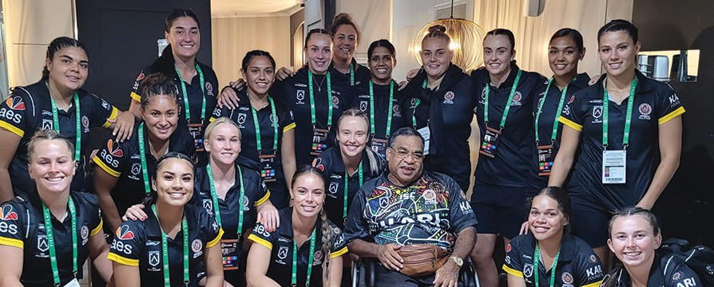
My first job was a paper boy – I sold newspapers in Brisbane City, what you now call the Queen Street Mall – at that time you could drive over the bridge and straight through Queen Street. I then had the opportunity to work at the State Library of Queensland, where I worked for 33 years. It was around the time that there weren’t that many people with disability in jobs – or in government jobs at least. By working at the State Library, this gave me opportunities to further help me to find out who I was, it helped me to identify stuff like being Aboriginal. Because I had the opportunity to do research, this assisted me greatly in finding out about my identity, where I came from, and who my people were. And so, I was able to help other people because of the knowledge that I gained and the opportunities that I had at the State Library.
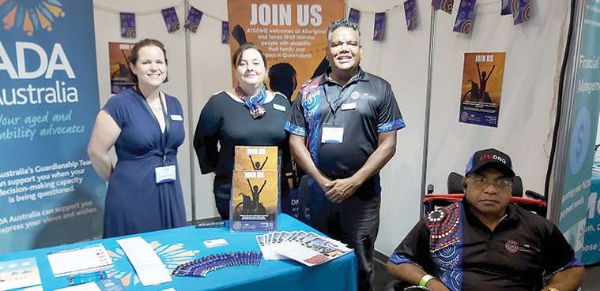
Willie with the Women’s Indigenous Rugby Team 2020.
Willie with ATSIDNQ colleagues at an event for International Day of People with Disability.
I was a wheelchair sportsman, competing in shotput and discus events. I represented Queensland eleven times, winning several gold, silver and bronze awards, as well as certificates for my achievements in wheelchair sport (shotput and discus). I was also a representative for Aboriginal people with disabilities on the Disability Advisory Council, set up by the then Minister for Disability, Anna Bligh. This role opened the door to other opportunities, like being invited to carry the paralympic torch. It was around this time that I was nominated to receive a Centenary of Federation medal, awarded to me by the Australian Government (given to me by John Howard).
Through my involvement with disability organisations such as CRU, I continue to be able to help and educate them about the issues that Aboriginal and Torres Strait Islander people with disability face. I often speak at events and deliver an Acknowledgement of Country. This brings together my two worlds or cultures. By continuing to be connected, this work supports me in building and maintaining rapport and relationships with these organisations.
Being in these roles has led to long term friendships. People like Jeremy Ward, Michael Kendrick, Mike Duggan (one of the first presidents of CRU) – these are the people that also helped me to get a better understanding of the ideas of building a better life.
More recently, I was able to apply and was successful in attaining funded supports (the NDIS) which meant that I was able to have more independence and to remain in my own home. It has also given me more opportunities to participate in community and continue to have the life that I wanted.
Some of what I’ve learnt by being involved with these organisations in the valued roles I’ve had, is through aligning myself with their core values. The roles that I have held in my life have felt like the right personal valued roles for me. I was able to apply these ideas ongoing throughout my life, and this helped me to get a greater understanding and awareness, which helped me to help others like SUFY, QAI and QDN.

In this article, Johanna reflects on her experience of being diagnosed with a mental illness but more importantly how she was treated by others afterwards. Learning about two SRV concepts: devaluation and wounding, has helped her to understand her experiences.

Helping Services Don’t Always Help - Jo’s Story
Johanna Grace has a lived experience of mental ill health and recovery and identifies as a survivor of childhood trauma and a survivor of psychiatry. Jo has been a compassionate witness for many years to the experience of devaluation for people diagnosed with mental illness and considers her ability to relate to these experiences as a strength in her work. Jo has worked in a range of human services and uses her knowledge of SRV theory in this work.
I first learned about Social Role Valorisation (SRV) when I began working in a disability support role at a large residential facility in the mid nineties. Several years later I was exposed to an overview of SRV theory in my university coursework, however it wasn’t until 2017 that I began to comprehend the value of SRV and the importance of its application in the lives of devalued people.
The catalyst for this change was my decision to attend an introductory SRV workshop titled ‘Towards a Better Life’ facilitated by SRV Senior Trainer Jane Sherwin. It was here that I began to comprehend the significance of the experience of ‘devaluation’ and ‘wounding.’
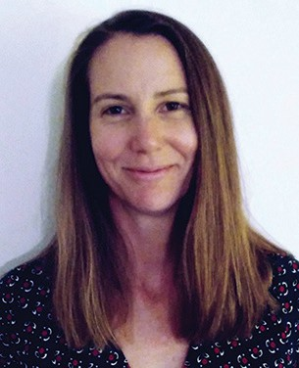
People judge one another, and when someone is seen to be different in an apparently negative way the person or group can be ‘devalued’ in the eyes of others. This often happens unconsciously and results in people and groups being treated badly. SRV refers to this poor treatment as wounding, the process by which people of devalued status are stripped of valued roles, cast into negative roles, and prohibited from access to the ‘good things’ in life.
Johanna Grace
By understanding that these negative life experiences (or wounds) are an impact of devaluation, I was able to reflect more deeply upon my own experience of mental illness diagnosis and the impact upon my identity, my relationships, and my opportunities. Almost overnight, in my early twenties, I became a devalued person- or a person of low social status. Not only was I impacted by my trauma-inflicted psychosocial impairment, I also began to carry the weight of these ‘wounds’.
I was seen as having less worth than other people. I was rejected by family, colleagues and peers. I was branded as ‘mentally ill’. I lost my sense of personal identity. I experienced isolation and loneliness. I was grouped with other people diagnosed with mental illness and separated, in a hospital setting, away from everyday communities. It was assumed that I lacked the capacity to make important decisions, so I lost my autonomy. These are just a few of the wounds that can be experienced by a person who is devalued, and they carry significant consequences. For example, I experienced a profound sense of alienation from others, felt myself to be worthless and expected to fail in any endeavour. These emotional and psychological impacts were not the result of my psychosocial impairment, but of the devaluation and the wounds perpetuated unconsciously by people- sometimes with the very best of intent.
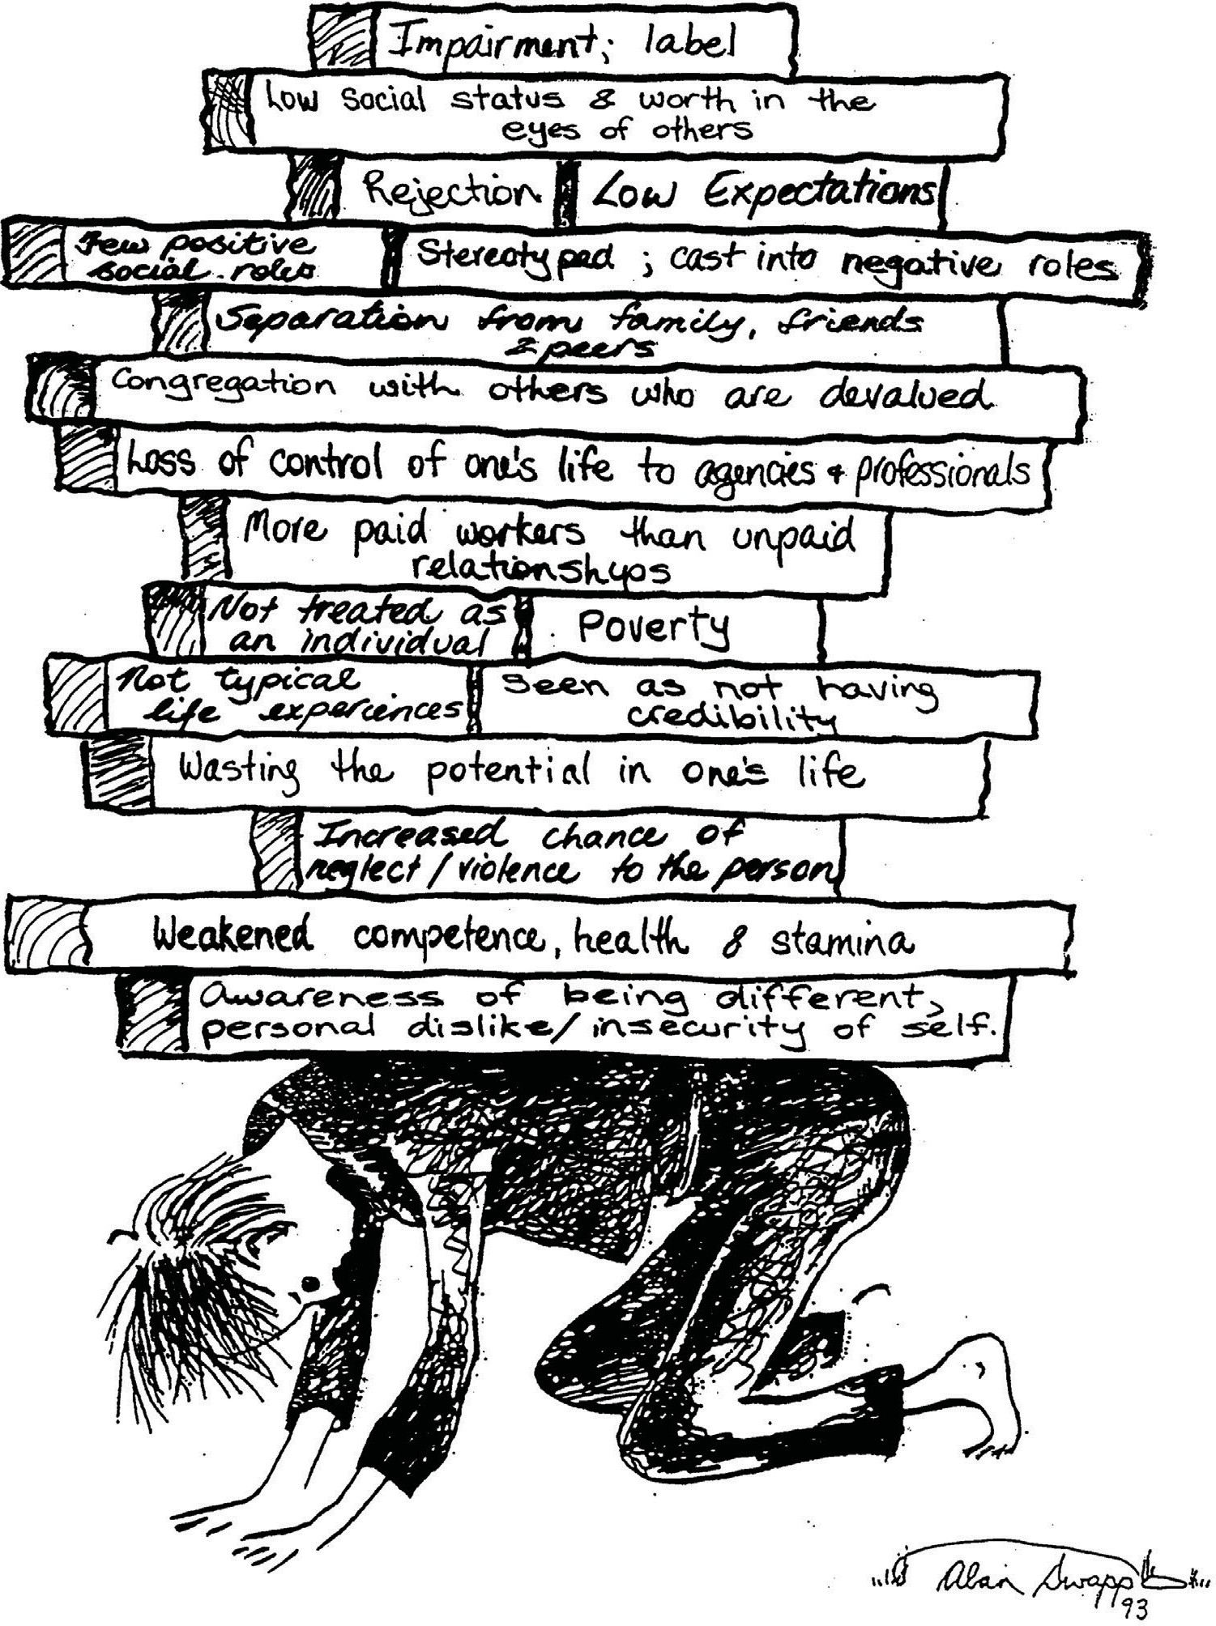
SRV provides us with an opportunity to consider how and why some people are denied access to the ‘good things’ in life. Devaluation leads to wounding, and wounding leads to loss. Loss of opportunities. Loss of identity. Loss of valued roles (e.g. friend, neighbour, colleague, team- mate). It has been helpful for me to understand the impact of wounds and losses, not just in my own life, but in the lives of other devalued people.
As a Psychosocial Recovery Coach, my lived experience offers me some insight into the challenges faced by the people I support. Learning about and applying the principles and strategies of SRV helps me to respond with empathy and compassion to the people I support instead of making false assumptions. When we understand the impact of wounds and losses we can engage with others in ways that reduce, rather than increase, the burden of carrying those wounds. We can facilitate, instead of blocking, access to the good things in life.

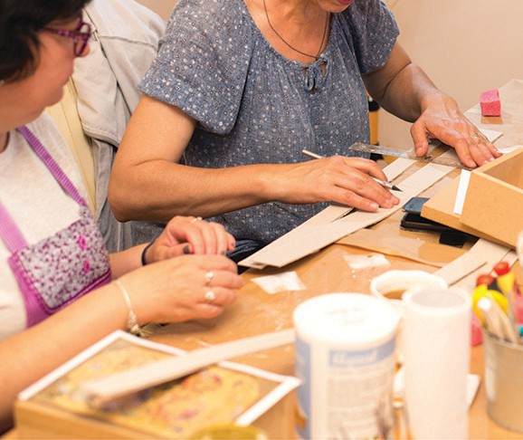

Power of Peer support
Being connected with a person or people who share and understand your experience can be a powerful thing. Sometimes called ‘peer support’, these mutual connections can help us feel more confident, more connected, and better informed, and can lead to an increased sense of control over our lives. Peer support can be as simple as two people having a conversation, or it can be networks and groups that host regular meetings. Being supported and supporting others can develop our confidence and leadership skills.
Members of the ‘Mums Group’ have shared their reflections on peer support in the following article.

A Story of Peer Connection - Mum’s Group
Mum’s Group is a group of parents who meet weekly. Community Living Association (CLA) supports these women in creating a safe space to share their parenting journey and to learn together as a group. Due to social barriers, mothers with intellectual disability can often face additional challenges that impact on their experience of parenting. These include housing instability, job insecurity, poverty, violence, and poor experiences with systems that make it hard to access help. Some women also experience involvement of Child Safety and not being able to have their children live with them, while others have their children at home but don’t feel they get enough support. Through connecting with their peers at Mum’s Group, the women are able to find a shared sense of belonging and support, while learning and upskilling, and speaking up on issues that affect women like them.
What is the best thing about being part of the group?
Everyone said how much they value the friendships they’ve made since joining the group. Taking the time out to prioritise their own needs, to be in an inclusive space where they feel welcome – and connecting with other parents who ‘get it’.
“My favourite part of the group is coming to group in the morning and seeing lovely faces, lovely new members coming here. And making new friends and the lovely food on the table for morning tea for all of us.” – Lisa
“Being part of group is the best thing because it helps you build friendships, it helps you to communicate with other people, even if you have a social issue and don’t have much friends, it’s helpful to make friends…If we’ve got any new members, we always talk about ourselves, and let them know our names – that way they know our names.” - Maggie
A weekly meet-up
The group meets each week, and together share morning tea, do art and craft, and learn about topics such as safe relationships, emotional regulation, boundaries, and what is happening more broadly in the disability space. A big focus of the group is on educating and improving systems to better support them and parents like them.
“Each Wednesday we have a different topic. It could be about relationships - relationships with your co-workers, your friends or your family, your partner, your kids. We could talk about risks or safety online and how to avoid scams online. We talk about ‘how to’s’ and strategies for meltdowns with your children. There’s a lot of topics we have done last year and we’re doing this year. We haven’t covered all of the topics, but we are still working on a lot more topics. We choose within the group what everyone wants to do.” – Maggie
“…I like to get strategies for my son… [he] has run onto the road and pulling people’s hands and I don’t know how to handle it… My son is 16 and I want more help and more support.” - Lisa
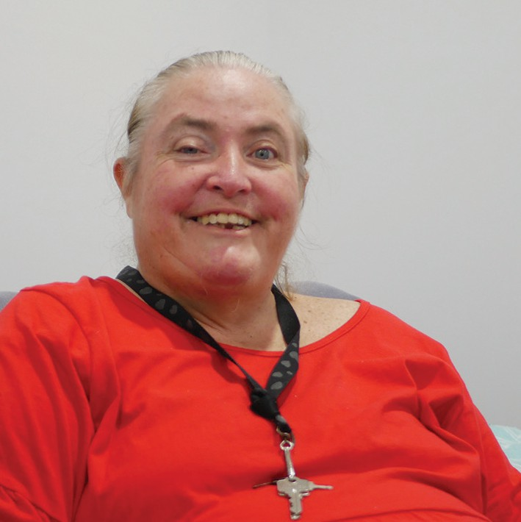
The group has hosted a range of guest speakers on topics of interest and together they work on projects as a group.
Lisa
Maggie spoke about how she feels she has grown through her involvement in Mum’s Group:
“Since joining the group – well I should say, WWILD* first and then this group – it helped me a lot. If it wasn’t for Mandy, WWILD and Mums’ group, I wouldn’t be this person. I wouldn’t be as strong. I wouldn’t be using my voice. I know I have counselling and support workers helping me at the same time, but I wasn’t using my voice. I wasn’t standing up for myself. I was always giving up. I wasn’t giving up my kids – I was still fighting for them…
[Now, I’m] going to Mum’s group all the time, it helps me. It helps me be a better person. It tells me that I need to stand up and fight. It’s not just my life, it’s my kids’ lives. They need to come home to their mum. I’ve become more independent and fight my life and stand up for who I am and help other families and other mums. And whoever joins this mum’s group, we’re there to help them, and not let them feel alone and scared. We want them to feel welcome and safe, and that there is hope. You never give up the hope. There’s always hope and you can fight for it. It might not happen, but you just have to hope.” - Maggie
You’re not alone
When we asked how life had changed since joining the group, women spoke about the idea that ‘you’re not alone’.
“I feel more happy, because I feel understood” – Anonymous
“My friend (Christel) said ‘come to group with me, you’ll probably get lots of things out of it.’ And I have.” – Lisa
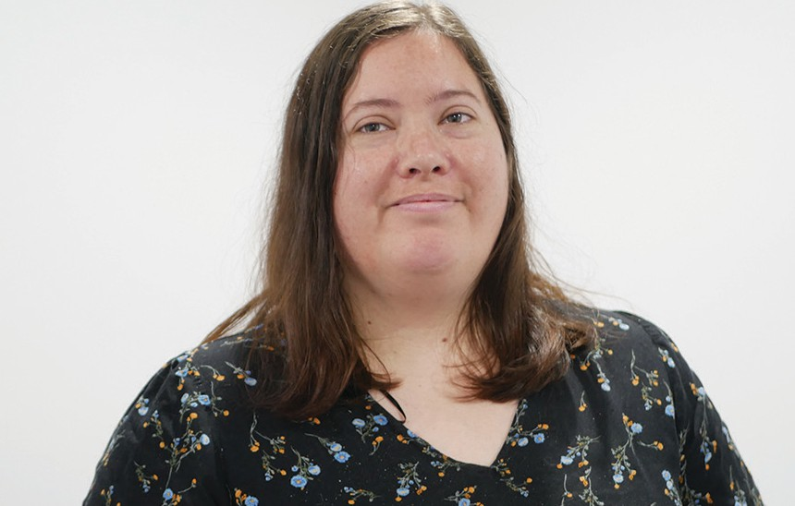
“Being in Mums’ group, I could leave any time I want, but I’ve stayed. It’s to build friendship and communication, and tick Child Safety’s box that I’m in Mums’ group... but it feels like family to me. And as Lilo and Stitch always say, “Family means family – no one is forgotten or left behind.” ... So that’s why I wanted to keep coming back. I feel at home here and I love it. I will keep coming back and I will keep growing.” – Maggie
Maggie
Giving back
“I love sharing lots of stuff, my story.” - Lisa
Many of the women generously share their stories, in an effort to raise awareness and share with people the voice of parents with an intellectual disability. They have spoken up at events such as conferences, Child Safety Forums, and the Brisbane Feminist Festival, as well as being involved in film projects. The women share about their achievements and help people to understand the challenges they face in parenting and the supports and systems that both work and fail them. They want to promote positive changes in the current child safety system.
“You share. You share yourself and your story. Whenever we do a recording, you are very giving of yourself and your story. Very generous with sharing and joining in”. – Support worker
“…We stand up and we use our voice in community centres, or if we’re in a meeting or we stand up and we talk about our stories and we say what we want to say. We say what jobs [Child] Safety should do better for issues around child safety, issues around parenting capital assessments. We talk about a lot of things around parenting.” - Maggie
“And I think the group is hoping to do that, give more opportunities for people to share. And there are people that have really enjoyed speaking in forums.” – Support worker
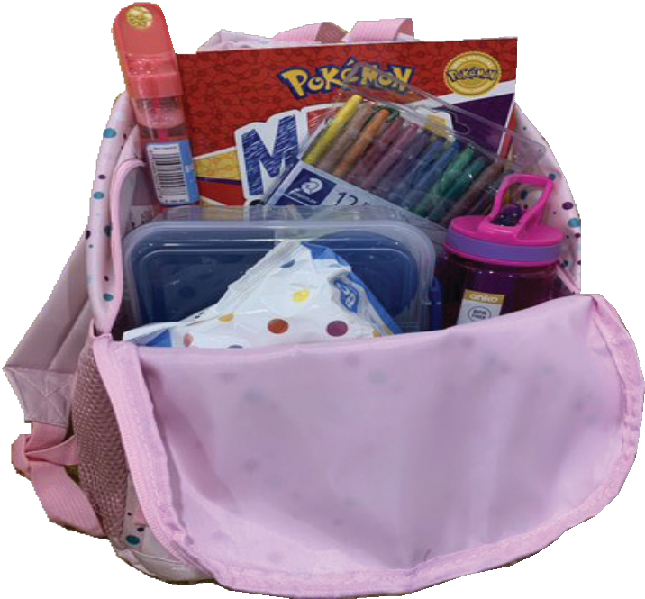
“And it gives the opportunity to speak up. They could be scared, they could be afraid to speak up, but when they come here, they learn to be strong and be brave and use their voice.” - Maggie

Bags for parents
Many of the women are also involved in a project supported by WWILD.
The women put together useful packs containing things like baby wipes, cream, nappies, books, recipes for school lunches, lunch boxes, snacks and sensory toys.
The idea being that these bags are available to support some parents with their contact with their child.
“…it was started at WWILD. We wanted to do something nice for mums who’ve never been a mum before. People who are struggling with finance and they can’t get a lot of stuff, we do bags for them. For new mums, young mums who are pregnant or just gave birth.
Each of the bags are different… so we built bags for babies, we built bags for kids as in children, and we built bags for young teenagers and adults.” – Maggie

*WWILD is an organisation that provides support and information for people with intellectual or learning disabilities who have been a victim or survivor of sexual violence or other types of crime or exploitation.
The following example from an organisation that supports young people, many of whom are in very vulnerable circumstances, provides another example of the value of peer support:

Men’s Group
In the past our organisation was able to form a Men’s Group. It involved a group of 4 or 5 men and a few workers.
They would meet once a week and do activities like bowling or fishing or going to the movies. Slowly over time the workers could take a back seat, just assisting with transport or supporting them to buy food for a BBQ…the logistics. This could occur because relationships or friendships had formed between the men.
The men started to work together towards their common goals and support each other to do this. The relationships and support that had formed between the men in the group was so strong that, even when the group had to disperse due to funding changes, the men continued as friends. Three or four even linked in with a worker’s co- op and still work together.
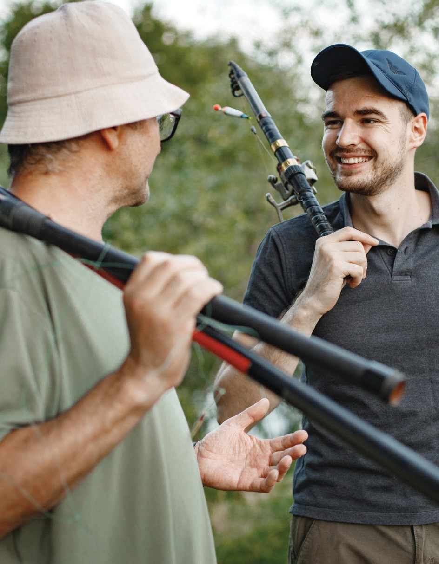
Photo by Helgy

3 High Quality Formal Support
Being present in community, connected to family and friends, contributing and belonging are essential elements of what it takes to thrive. For many people with disability a layer of formal support is also necessary for their daily wellbeing.
The quality and delivery of this layer of support is critical if people are to get the support they need and if the four themes are going to work well together. The shift to the NDIS and individualised packages has impacted the ability of many organisations to respond to people with multiple barriers. It has exposed the inadequacy of ‘the market’ to provide for our most vulnerable citizens. Providing high quality support takes time; it takes investment in staff, and it needs to be flexible and responsive. Current funding mechanisms and assumptions often do not match the life experience of people dealing with multiple life barriers.
A number of underpinning values and practices, critical to quality, were identified through our research. We know that holding true to these in ever changing funding and support environments is challenging and requires commitment.
When we talk about high quality formal support, we refer to formal support that is:
- Based on the person’s vision: The person and those closest to them aim high as they set the direction for all decisions that are made in the person’s life.
- Directed and managed by the person: The authority remains with the person or those closest to them.
- Delivered by person centered workers: Workers who are skilled and have opportunities for ongoing training, supervision and reflectvie practice. Workers adapt to people’s changing needs over time. They understand the primacy of informal supports and their role in building those.
- Transformative rather than transactional: Not just turning up for a shift but working to make a difference for the person.
- Honouring dignity and privacy: The person with disability makes, or is supported to make, decisions. Workers talk with the person rather than about them. Privacy and confidentiality is upheld.
- Congruence and Accountability: Support that ‘walks the talk’ (doing what you say you’re going to do).

AMPARO Advocacy in Brisbane has worked with people with disabilities from culturally and linguistically diverse backgrounds for twenty years. A recent evaluation highlighted the key elements of their work. The following article is based on learnings from that report.

The Work of AMPARO
AMPARO Advocacy is a small not for profit community organisation that provides individual and systemic advocacy with, and on behalf of vulnerable people from culturally and linguistically diverse (CALD) backgrounds with disability. In recent years they have taken on capacity building to complement and strengthen their advocacy work. AMPARO is based in Brisbane and works across Queensland.
AMPARO works with and alongside people from countries such as Vietnam, Somalia, Iran, the DRC, Nepal, Bhutan, Egypt, Iraq and Afghanistan, who have come to Australia as refugees or have settled here under the Refugee and Humanitarian Program. These people often face multiple and complex layers of disadvantage, and experience significant levels of vulnerability. Having limited English proficiency, and additional language and cultural needs, it can be much more difficult for individuals and their families to access mainstream services, and disability specific funding.
An independent evaluation carried out by The Hopkins Centre (Griffith University) found that AMPARO’s capacity building work is underpinned by values of social justice, human rights, the social model of disability and culturally responsive practice.
This evaluation reviewed a project that involved connecting with people from CALD backgrounds who were not receiving the information, supports, and services that they were eligible for. The project took a community outreach approach. The majority of the people engaged by AMPARO during this project had experienced significant trauma, had low English proficiency, and had little to no access to disability supports and services in the past. They were likely to be experiencing socioeconomic disadvantage and significant barriers to community and economic participation. Many people were also experiencing housing stress or homelessness, and domestic and family violence.
The evaluation found that this project was successful in achieving many positive outcomes. Beyond assisting people to receive the supports and services they were eligible for, this project worked to raise people’s expectations around what constitutes a good or ordinary life, and helped people find ways to become more a part of their local community. It also assisted people with enrolling in TAFE, finding employment, accessing public transport, connecting with neighbours and improving English language skills.
Several challenges are involved with this kind of work. These include engaging appropriate language services for languages less spoken in Australia; working with insecure visa status; the sensitivity required to work with high levels of vulnerability; negative previous experiences in people’s home countries; and allowing the time required to build trust.
Jack and Clémentine’s story
Jack and Clémentine’s story provides an example of AMPARO’s approach:
Jack (10) was due for his plan review. He had had the same Local Area Coordination (LAC) partner for several years. The LAC’s role was to help Jack create and work towards goals, build capacity to make his own choices and access the supports he needed. Jack’s family, including his mother Clémentine, were upset about how they were being treated by the LAC as she was disrespectful of their culture. They felt that they had to put up with it because they were afraid to complain in case it meant that the funding would be reduced in the future.
We (AMPARO) did not advocate for Clémentine, but we were able to help her understand their rights and the complaints process. We stepped her through the process of making a complaint and supported her to do this. She was listened to by the LAC’s team leader, and they now have a new LAC. This has taken away a lot of stress and anxiety for the family and they have learned how to make a complaint if they are not treated fairly. Clémentine feels empowered to speak up in the future.

Clémentine learnt about her rights including that there will be no negative consequences for making a complaint and asking for change. She was fearful of doing this in the past. In her culture it can be seen as impolite to directly tell someone that you are unhappy with them. The respectful interaction with the LAC’s team leader reassured her she had done the right thing.
The work of AMPARO can teach us many things about how we can better support people from CALD backgrounds.
What constitutes effective support for people with disability from CALD backgrounds?
- Culturally sensitive approach: Engaging certified interpreters and meeting people in locations suitable to them. Providing information in a way that they can understand.
- Capacity building approach: Community engagement by Multicultural Engagement Workers to connect with people from CALD backgrounds with disability and their family members and gain a deep understanding of their needs and goals. The worker then assists the person or family to build their own capacity. Often, this includes how to understand and uphold their rights, particularly in relation to increased knowledge and confidence to exercise choice and control over disability supports.
- Collaborative approach: Collaborating with community leaders, health and education services and disability service providers.
- True listening: Workers listening to and effectively engaging, in order to more deeply understand the person’s needs, unique life experiences, context and aspirations.
“AMPARO is so much helpful. They are committed to assisting people in need, even with complex situations.” (Participant survey)
- Vision: Using a more creative approach when developing a vision
- Organisational culture: Within the organisation, people take a supportive, reflective, collaborative approach. An adaptable continuous improvement mindset keeps the organisation responsive to emerging needs. Reflective practice also helps people to be aware of the challenges affecting the work.
- More time: Significant investment of time to build trust and rapport with people. The role of the worker than then also be to communicate this deep understanding of the person’s life experiences, their needs and aspirations to other stakeholders.
- Lower numbers: While working more deeply with people requires more time, this also places a limit on the number of people an organisation can work with. There can be a tension between this and the expectation or desire to support a larger number of individuals.
- Home visits: Offering people the option to meet in their own home, at a time suitable to them. Few other services offer this, which presents a significant barrier to accessing services for many people from CALD backgrounds.
“Most important was the visits to my home and talking and listening to me.” (Participant Survey)

Farhad’s story
Farhad is a 61-year-old man, from Iran. He has an intellectual disability along with a psychosocial disability.
Farhad resides alone, and although he has family around the area, he chooses to seek out people involved in the street culture in the area. At times, he forgets his medication and gets caught up with people who are homeless. Sometimes, Farhad tries to take his own life when it all gets too much for him and he spends time in care. When we (AMPARO) met Farhad, he had been in hospital for a period due to trying to commit suicide. He had been a little estranged from his family due to him not taking his medications. He is a friendly gentleman with a passion for walking and seeing new sights and chatting with people, hence why the people involved in the street culture are so interesting to him as they would speak with him. He was trying to sort out what best to do with his available supports. We would catch up with him and we’d chat about his needs, what he would like to do in the future, and we would do vision planning sessions with him. He enjoyed these discussions, in particular learning about his rights.
Over a period, he started to say how his support worker would only ever take him to the same coffee shop, on the same day and same time every week, although Farhad had asked him to take him other places. He realised that he was not being listened to nor respected. We would encourage Farhad to make suggestions to his support worker, and so we started up a list of what he would like to do on that he could suggest to the worker.
After several rebuttals by the support worker, we again spoke about his rights, and how important it was for him to take control of his life, and that he can choose what support worker he would like and who would collaborate with him in a supportive, embracing manner. He requested another worker from his support provider, stating:
“I’m not happy with my support worker, he doesn’t listen to me, and he doesn’t take me where I would like to go. He only takes me to where he wants to go, and he sees his friends there. “So, I want someone for me!!”
Farhad was introduced to another support worker the next day and fortunately this was a better match and they clicked. The new worker has been able to support Farhad to be involved in new adventures where he is safe and enjoying life, along with having developed better relationships again with his family.
Farhad became empowered by learning about his rights. Now he is the one to take control over his life and knows that he needs to be part of any discussion where decisions are being made for or about him. Farhad is a lot more confident in speaking out and looking for a better life and is learning about available support including the NDIS, and how it can help him meet his needs and goals.

In this article, Leanne and Benita share how their organisation works with people to maintain authority around the supports they receive, to support people to live their lives the way they choose (in their homes and communities) and to do this in innovative and flexible ways.

Finding a Path to Culturally Appropriate Service Delivery
Leanne Burke has worked at Staffing Options since 2006, establishing the host agency for self-directed support and has collaborated in transitioning the principles of self-direction and shared management into the services provided under the NDIS. Prior to this she worked for 12 years in coordination roles for small family & user-governed services including Homeswest and Lifestyle Options Inc.
Benita Bierzynski has worked with people with disabilities and their families for 20 years. She currently works as a support coordinator at Staffing Options, prior to this she worked as an individual advocate at SUFY (Speaking Up For You) for 13 years.
Mahesh and his family relocated to Australia several years ago from Nepal. English is not spoken in the family and disability is viewed differently in their culture. These factors compounded the problem for Mahesh’s family who had no understanding how to navigate a complex system that is not culturally sensitive or that Mahesh had a right to support that was adequate to meet all his needs. Historically, Mahesh and his family had experienced harm at the hands of government systems. This means they do not trust easily and are reluctant to connect with anyone who might be seen as associated with the government. This mistrust and reluctance to connect was compounded by initial poor dealings with service providers in Australia creating another barrier. Further to this, Mahesh had experienced physical harm due to neglectful support.

Mahesh and his family had a very narrow view of what good support could look like and the range of options available to them. Their understanding, from the advice they had been given, was that the only option for Mahesh other than living at home was a group home. This was viewed as culturally inappropriate and something they did not want to explore or engage with. They opted out of the system that was not listening to them, did not provide them with a voice and frequently told them what is best for their loved one. Mahesh’s family had limited opportunity to experience good family support let alone explore a vision for a good life due to language, culture and personal experience. Mahesh’s funding was not being used and assumptions were made that the family just didn’t want support or that Mahesh didn’t need or deserve good support.
Up to this point the NDIS, the national funding scheme, had seemed non-representational and confusing to Mahesh’s family. Most communication with the NDIS and previously engaged providers had been done without interpreters. Letters and plans were sent in English rather than being translated.
Mahesh and his family were connected to Staffing Options Support Coordination services by a Brisbane based advocacy service that the family was connected to. The Support Coordinator, a role that is funded by the NDIS, understood that given Mahesh and his family’s experience, trust would take time to build, and that work would need to be done in small steps at their pace. She worked with the advocacy service to help identify other people the family would trust, like a preferred interpreter who would be engaged in all communication with the family. This consistent approach allowed for rapport and trust to build over time.
This approach led to deeper conversations around Mahesh having a good life, what this could look like and who could assist them to achieve this. The natural authority of Mahesh’s family was honoured and respected.
As the same interpreter was used for all engagement they have built a reasonable understanding of the funding system, and are able to explain things in a more culturally appropriate way when required. What Mahesh’s funding looked like and how it could be used throughout the plan period continued to be difficult for his family to grasp. The simple act of providing a translated financial report allowed them to really see for the first time what might be possible. Mahesh’s family started to make decisions that opened up his world – they started with small amounts of support and built confidence over time.
Through having good and accessible information, Mahesh is now utilising a range of supports from different sources. Mahesh’s Support Coordinator has helped gather a team of likeminded therapists and practitioners who also value using an interpreter for all communication with Mahesh and his family. Everyone works as a team to support Mahesh and his family achieve his vision.
Rather than use a traditional service provider for Mahesh’s personal and community supports, Mahesh’s family chose to engage a bilingual Contractor, Dinesh. Dinesh sub-contracts to other workers who, where possible, speak the same language as Mahesh. Mahesh’s supports require a high level of safeguarding. Dinesh works autonomously with Mahesh and his family but reports regularly to a Support Coordinator. The Support Coordinator assists with resourcing Dinesh. The Support Coordinator copies Dinesh into all correspondence with the family and vice versa to improve communication and understanding. All therapists and practitioners have a link to the Support Coordinator and know how to raise their concerns.
The role of the Support Coordinator is to make sure that all people engaged are doing the right thing by Mahesh and his family, provide oversight about Mahesh’s funding and be the link and buffer to the agency that provides the funding. Although Dinesh was engaged as a contractor, he could have been directly employed as a Key Worker within a self-managed support arrangement or via a service provider that values and supports people to direct their own service should the current arrangement need to end.
There are clear positives to engaging a bilingual worker, such as providing culturally appropriate support. It’s also important to be mindful of the amount of power a bilingual worker can have, and their role in faithfully representing the person’s wishes and accurately translating what others are saying to them.
In 2024, the intention is for the Support Coordinator to engage an independent interpreter at regular intervals to have a conversation with Mahesh about any issues relating to their supports and services and to provide remedies for any issues raised. We (Staffing Options) also ensure that at least one other Support Coordinator in the team knows and understands the arrangements in place and have a relationship with the family as a back-up. The Plan Manager is also aware of the arrangements in place and knows who to contact should issues arise.
The path for Mahesh would have been very different if the group home was the option taken up. This would have likely caused an erosion of family relationships and cultural identity for him. In summary, there are a few simple strategies that were fundamental to realising high quality support for Mahesh:
- The consistency of services being linked to Mahesh via an interpreter
- A willingness to work collaboratively
- Having a worker in a key role who is bilingual
- An understanding that it is necessary to review and renew safeguarding strategies regularly
All of these factors continue to provide Mahesh and his family the opportunity to move towards their vision for a good life.


Photo by Josh Withers

Transformative rather than Transactional Work
Some people with disability are able to hire workers to do a set task for them at a set time. However, for people who face multiple life barriers, there is often a need for work that goes beyond these straightforward transactions. This work demands skilled workers, time and responsiveness. This work requires creativity and flexibility, allowing for the opportunity to ‘give things a go’.

The next article from Morrie and Shaun from ARROS, Community Living Association, speaks to the importance of high-quality formal support in a crisis situation.

The ARROS Service Model
Long-term, Relational and Crisis Responsive
Morrie O’Connor has been the coordinator of Community Living Association (CLA) since 1989, and Shaun Parkes is a social worker in the ARROS team at CLA. CLA works with people with intellectual/ cognitive/learning disabilities and young people at risk of significant social disadvantage, in the areas of housing, income, safety, relationships and physical and mental health.
ARROS is a small service that was established by Community Living Association in 1994 to work with people with an intellectual disability who were homeless or at risk of homelessness. The service was established following a research project and then a pilot project funded by the Queensland Department of Disability, which later block funded this work.
A significant number of young people that ARROS came into contact with were homeless and had been wards of the State. A number of these people had been provided with substantial individual funding packages on exit from Child Protection, however they had subsequently become homeless, and their funds were unspent.
ARROS was able to expand its service by connecting with and offering support to these young people. ARROS also successfully engaged with the Department of Child Safety to receive a small amount of transition funding to support young people with intellectual or other cognitive disabilities who were exiting Child Safety and were already homeless or at risk.
People with an intellectual or cognitive disability who become homeless are examples of the ‘Inverse Care Law’ – “the greater the need the less the care” (Munro, 2019). Often, as well as homelessness and disability, these young people will experience family dislocation, poverty, exploitation, child protection, loneliness, drug and alcohol issues, criminal justice contact, and poor physical and mental health. For a number of reasons, agencies and services often find it difficult to work with and connect with them and funding can remain unspent.
The ARROS service model was and is characterised by the following elements:
- Relational – Recognising the need to build a relationship of trust.
- Proactive, assertive outreach – Services need to be proactive, persistent, gentle and sometimes quite long term in outreaching to form a relationship that leads to work on issues.
- Holistic – The worker needs to be responsive to just about any opportunity to forge a working relationship. ‘That’s not my job’ or ‘Our service doesn’t do that’, just reinforces people’s previous experiences of lack of support and the idea that the worker is not someone who has anything to offer.
- Crisis responsive – Crisis opens up possibilities to build relationship, and to support the person to build capacity towards stability.
- Long term – The issues confronting people are complex and it takes time. Two steps forward, one step back is a reality of their social environment.
- Stable worker, stable team – Long term work is helped when workers are stable. A stable team offers support to the work and the opportunity to develop relationships with other workers in the team.
- Understanding of and ability to work with trauma induced and challenging behaviour – If workers and services seek to exclude people whose behaviour is challenging or impose restrictive and punitive reactions it is not likely that an effective working relationship will develop.
- Skilled workers – Workers need to have skills and aptitude to work with people with complex needs. ARROS largely met this need by employing workers with Tertiary level training.
Cleo’s story
Cleo is a young woman of twenty-five years, who was referred to ARROS at age twenty. At this time, she was experiencing homelessness, suicidal ideation, a history of trauma and trauma based behaviours, involvement in a domestic violence situation, and underutilization of her paid supports. Her poor physical health and her cognitive disability impacted her capacity to self-manage, maintain positive social interactions, learn, communicate with and understand the communication of others. Shortly after beginning work with ARROS, she was charged with criminal offences, drug offences and breaches of the Domestic Violence Order in place with her ex-boyfriend.
Cleo’s support needs were complex, however there were potential strengths and assets to be drawn on in the work. Cleo had completed grade 12, she had a relationship with her boyfriend and family for several years, and she had people she couch-surfed with.
Our approach to working with people in a situation such as Cleo’s often follows the following guiding principles:
1. Proactive outreach to connect and repeat, repeat, repeat
2. Develop a working relationship
3. Build the relationship with the person by being useful
4. Support through crisis
5. Hold and develop the relationship through trauma responsive behaviour
6. Achieve some tangible outcomes that are meaningful to the young person
7. Develop plans to achieve change
The beginning actions were outreach, building the relationship, and supporting her to deal with systems – small tangibles. Enveloping these actions was daily responding to Cleo’s suicidal ideation. Cleo’s communications about committing suicide were extremely concerning as she had the means. This resulted in a high level of stress in the work for staff. Workers were never able to walk away from a suicidal ideation interaction with Cleo feeling confident that she would see it through the next day.
They always walked away with the knowledge that she had the means, she was impulsive and that she might carry through. This was an enormously difficult place for a worker to be in. ARROS provided almost daily debriefing and supervision for the workers. Our level of concern for the worker led us to assign two workers to work with Cleo. Risk for Cleo and risk for workers were constant and required ongoing safety planning.
The ARROS workers developed a working relationship with Cleo, supported her through her surgery on an existing self-harm injury, accessing legal aid and through a court process and maintaining probation. They supported communication with service systems. The workers were able to offer Cleo emotional support and assist with safety planning around substance use. Our approach was also to assist her with identifying life and employment goals, and in finding ways to begin to use some of her paid supports and link her to a TAFE course.
Unfortunately, the organisation providing direct support for Cleo to attend TAFE provided a different support worker each week. This unpredictability placed considerable stress on Cleo and she discontinued her studies. ARROS continues to work with Cleo to achieve her goals.

Work with people with an intellectual disability who are homeless or at risk requires longevity, relationship building and outreach.
Photo by Everdeen Li
Cleo’s story reinforces that at the heart of high quality paid support that is long term, relational and crisis responsive are workers who are person-centered. People need workers who are able to take the time to get to know the individual and their particular needs, interests and aspirations. Families and individuals have emphasized the importance of having choice over the support workers who enter their home and having consistency in those who provide support. This is particularly important for people like Cleo, who already live with a high degree of uncertainty and stress in their lives.
However, a difficulty with our current systems is that they are not established that way. By contrast the following is more often the case:
- They are often established so the majority of direct day today support is provided by the least trained, often least supported, sometimes casualised workforce, without the key stable relationship or relationships that are needed for continuity.
- These workers are responsible to Managers who often require workers to carry out very specific roles which boil down to “supply x hours of funded support for young person’s support activity and move onto the next job”.
- There is very little that is autonomous for these workers. They do not step outside their designated role even if it is clear the person may need different or other supports. Often, they may not even feel empowered enough to report concerns to their Managers. If they do, the Managers response may well be, “We are not funded for that. It is somebody else’s responsibility to seek additional funding for that need.”
- If additional funding happens to be sought, then there will be a lengthy assessment process.
- The system fails if there is no one who has a key relationship with the person. People like Cleo fall through the gaps because they don’t have these key relationships, family, informal or professional.
- Because people with complex support needs often demonstrate their needs through behaviour that is difficult for others, they receive judgement or blaming with little understanding of the cause of their difficulties.
- People with complex support needs have difficulty gaining specialised support from therapists. These difficulties arise because the therapists themselves may ‘cherry pick’ people with less complex support needs. This has been reported in a number of studies in relation to NDIS supports).
Over 30 years, ARROS has learnt a lot about what makes a difference for people like Cleo. The challenge is how do we offer them the high-quality person-centered support they need at a time when the current systems are not conducive to that.
It is not enough to hope that they will be lucky enough to engage with a community relationship or relationships that offers them the safety and the recognition they need. If we don’t find new ways, their outlook is bleak.

4 Impact of Organisational Structure
The quality of formal support can be affected by the type of organisational structure that is responsible for delivering it. An organisation’s ability to stay true to the underpinning values and practices that we discussed in the last section is in part determined by factors such as their size, and their governance structures.

Size matters
Dr Wolf Wolfensberger, in his work on Moral Coherency cautions that over the long term, a pattern can often be seen in social systems (including human services) that trends towards a move from:
- Small to large
- Informal to formal
- Having few systems to increasing bureaucratisation.
The risks of this in human service provision can include decreases in individualisation, care, and manageability.
As a human service organisation becomes larger, it can become harder to respond to the uniqueness of each individual that it supports. Responses to individual people can become segmented and regimented. This is often seen when people’s lives are formalised and divided into behaviour plans, meal plans, medication plans and plans for community access.
Another impact of decreasing individualisation is that staff may feel separated and less personally responsible for outcomes, which then impacts on the quality of support they provide.
More formality in services can also mean that more rules are needed to manage the increasing complexity. These rules can drive out individual creativity and flexibility because they mean that workers have to stick to strict procedures. These trends are concerning for anyone who requires support but even more damaging for people who experience multiple life barriers.
A smaller, flatter structure can mean decisions are made closer to the people being affected, and the person with disability can be kept at the centre. Staying alert to ‘prioritising people over process and efficiency’ is critical in any size structure.
Staff that are engaged in and committed to their work over longer periods of time can build a greater degree of trust and more authentic relationships with the rest of the team and the person they support. Organisations that embed positive values across the organisation, including establishing shared values amongst all staff have a better chance of responding well.
This is not to say big is bad and small is good. It is much more complicated than that.
While there are many benefits to being small this is not in itself a guarantee of quality. Small organisations are also vulnerable to shifts in funding, maintaining compliance with regulators, and succession planning in governance structures. Large organisations can be more robust but then find it challenging to maintain the ability to respond individually to the people they serve. Some large organisations, mindful of these risks, divide their organisation into groups or teams, and allocate and train their staff carefully. These structural decisions can reduce the risks that can come with growth. Some small organisations have opted to be hosted by larger organisations thereby reducing the burden and cost of compliance while maintaining independence. Funding needs to be offered in a way that supports the option for smaller organisations to thrive in the NDIS.

User and Family Governed Organisations
In Queensland, some groups of people with disability and families came together to develop and run their own organisations. Some of these organisations pioneered new and effective ways of providing support as early as the 1980s.
Rather than decisions being made by others, key decision making, and organisational governance was the responsibility of the users of the organisation, their family members, and close allies. Most of these organisations were small, serving a maximum of about a dozen individuals. The structure was often simple and flat, with one coordinator, plus support staff for each individual.
The quality of support offered was high and the ability to blend formal and informal supports together to create a more typical, spontaneous lifestyle was impressive. Yet these organisations face their own challenges, such as fatigue from managing daily life as well as the organisation’s governance. Other challenges include sustaining quality over time and through succession, and possible conflicts of interest (and perception of conflict of interest) that come from small groups of people working closely together.
Examples of these family and user governed organisations that have existed in Queensland include Homes West and Lifestyle Options. Later initiatives, Kalpana in Queensland and One by One and Living Distinctive Lives in Victoria were hosted by larger organisations. This provided important behind the scenes support but kept the decision making with the people concerned.

In this article, Leanne, who was engaged as the first co-ordinator at Homes West and who was involved with a number of these organisations, reflects on her experience with Homes West. Firstly though, a few words on how Homes West began. A parent in suburban Brisbane said ‘enough was enough’. She wanted better for her daughter. She linked with another parent and together, in 1990 they put a submission of intent to Community Resource Unit. CRU agreed to work with them to present an alternate type of accommodation.
They called a public meeting in the local school library, which was well attended. From there a steering group was formed and Homes West began. While this organisation was not established by, or designed for people with additional life barriers, the learning from their experience could be applied more widely.

Lessons from Homes West
Leanne Burke grew up in a typical family of mum, dad and 3 children in suburban Brisbane. What was not so typical was the different experience of her sister who lived with an intellectual disability. In 1989, Leanne began working for family support services. She has supported many people who have had lived experience of othering and wanting better lives, inclusive education, and supports that assist their family member with disability to live in the family home. Leanne currently works at Staffing Options.

The Homes West Association was an Incorporated Association operating in Brisbane from 1991 - 2018. Around its inception, the organisation was block funded, with thirty hours of coordination and forty support hours between three people. It grew over time and eventually supported fifteen families to assist their family member establish their own home and live as a valued member of their local community.

The mission statement while not simple was clear - to work with families, to support people with a disability to establish and to live in a home of their own and to be included as active and valued members in their local community.
The Management Committee were family representatives of current and future service users. Before Homes West had an office, they would hold meetings at CRU and Anne Cross, the Director of CRU at the time, attended most meetings – Anne was trusted by the group and provided good guidance.
‘Family Agreements’ documented what each family wanted and expected from the service and this was different for each person. A strong belief in the natural authority of families required an allowance for time for family values, practices and standards to be clarified, understood and upheld so that trust could be built in the people around them.
Homes West had no standard model of service, but rather, there were common elements that were agreed to. Defining what was the business of family and what was the business of the service was part of daily conversation. Families participated in the selection and training of workers. The organisation was the formal employer, and the role of the Coordinator was to make sure staff were supported, well trained and understood their role. The Coordinator also managed dismissal processes and brought any issues to the committee and broader group of families so that any policy or procedures could be remedied.
To aim for a sustainable home, Homes West supported families through three phases:
Phase One – Planning a Lifestyle
Phase One involved lots of planning forums. Each person engaged an external facilitator who assisted with planning. The organisation also held annual forums where people being supported, family members, committee members and workers came together to review and plan the year ahead. Individuals planned with their support teams (and presented this to the group) and committee members spent time reviewing policy. The focus was on home, quality time with family and friends, and what the local community had to offer, as well as community contribution. The Coordinator was most interested in how the formal support could assist people to put their plans in place. We used measures like ‘circles of participation’ diagrams to record new and strengthened relationships.
This first phase also included engagement of support workers but with the thirty funded hours for Coordination, there was a lot of time to spend with people and families. There was so much more freedom to be creative when there was very little paid support involved.
Phase Two – Establishing a Home
In Phase Two, any opportunity to trial living out of the family home was taken up e.g. house sitting, staycations. People did their shopping, banking, and other business in the community they planned to live in. Sue’s family were the first to feel they were ready to take out a six-month lease on a house in a neighbouring suburb. Initially, Sue’s parents slept over at her house so that her funding could be used to support her build her life in the community. When Sue started pulling out the line that her parents better ‘go home and feed the dog’ – a polite way of saying I don’t need you in my home anymore – they knew that they needed to look at other options while seeking increased funded support. She had three different housemates over several years. After 28 years, Sue still lives in her own home and her brother and sister have become the key players and decision-makers in her life.
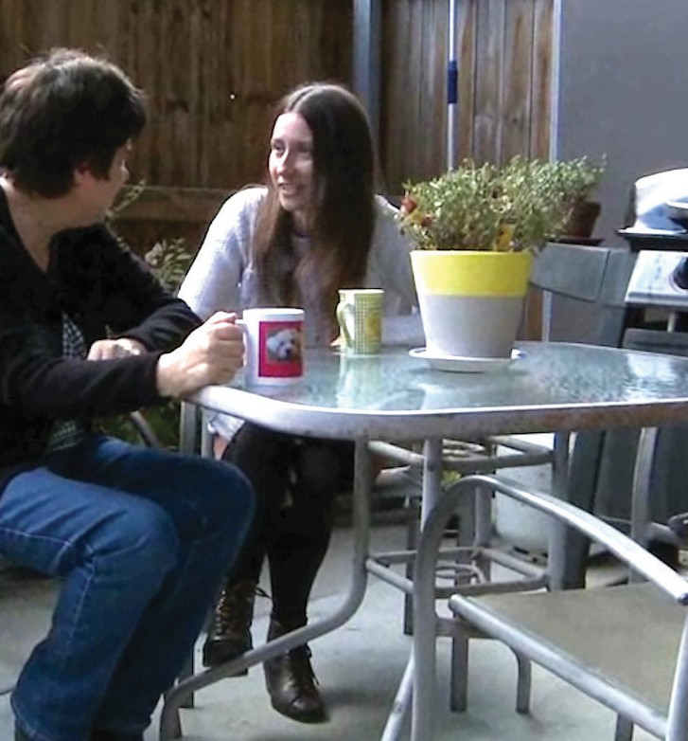
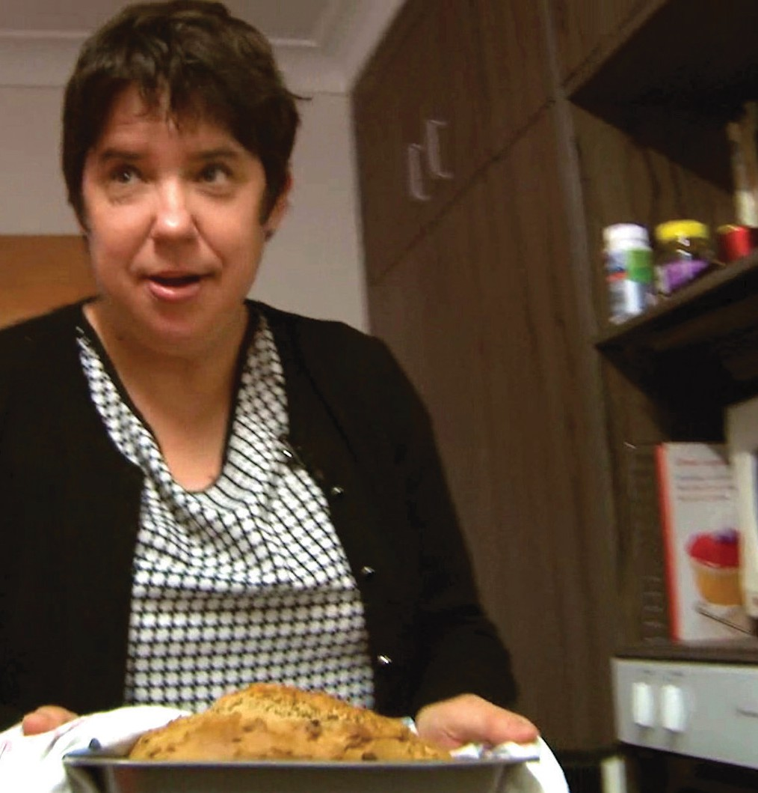
Each person had a calendar rather than a roster. Family occasions, events, dinner invites and regular commitments were added to the calendar before workers were rostered. Workers understood that being added to the calendar meant that they had to be able to provide the support required to facilitate the person’s life on that day or evening.

Phase Three – Anchoring in Community
The third phase of establishing anchors in community really started in the first phase. Homes West’s philosophy meant that there were always opportunities created to engage with younger family and friends, opportunities to strengthen relationships with community members with invites to celebrations. It was the business of family to plan for others who knew and loved the person to carry this business into the future with them and beyond them. Homes West created opportunities and practical assistance for people to develop networks.
There was an ever-present understanding of the vulnerability of the person - bad things happen in ordinary life and the consequences may be more severe, due to the nature of disability or previous negative experiences. Homes West planned for success and dealt with the inevitable issues faced when dealing in an environment where devaluation and discrimination of people with disability was still predominant.
There were tensions when the natural instinct of families was to protect and keep their loved one safe. The persistence and resilience of the person to stamp their own authority over their own life with respectful support allowed for risk taking. There was also a conscious investment in the development of support workers.
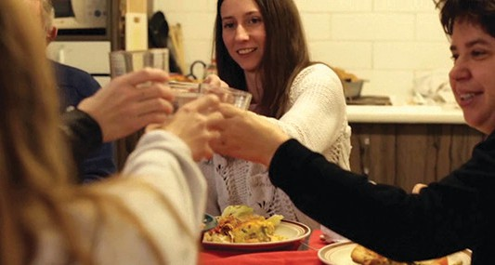
Other similar small organisations have existed over the years – locally in Brisbane this has included Kalpana, Lifestyle Options, and the Collective Action Group. However, changes to funding bodies made it difficult for many of these organisations to continue. While some opted out earlier, some got bigger, others started doing things to cope with the economies of scale required to stay viable.

Some of the key learnings from my experience include:
- Dream big. Having a vision or mission statement that is clearly understood by all expands the thinking beyond traditionally held views. Start with the question ‘how do you want to live your life’ rather than what supports/services will make life easier/better.
- Plan intentionally for the sort of life the person wants to lead today and in the future before planning the paid support they require
- Careful planning. Success came from the careful planning and laying foundations for a good lifestyle before establishing home and then ensuring each person had anchors in the community and planning for generational change of leadership.
- Focus on friendship and freely given relationships. Don’t put all your efforts into formal paid support. People who are paid to be in people’s lives come and go – it is an important part of their paid role to facilitate the person with disability to develop friendships and freely given relationships.
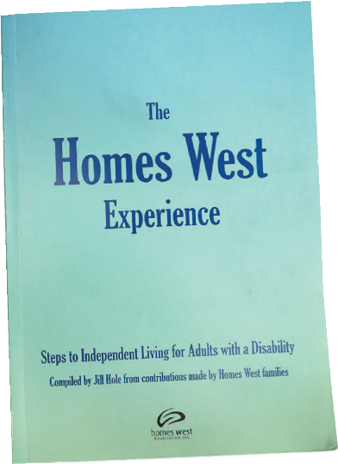
- If people within Homes West waited for the funding to be right not much would have happened. People were demonstrating the lives that they could lead – the funder took notice.

Conclusion
We hope that this collection of stories, reflections and examples has prompted you to think more about how these four themes need to work together and build on each other for people to thrive. This is important for all people with disability but will particularly benefit the people with disability in our community who will not just be able to ‘show up’, apply for funding and make the most of the NDIS and other services and systems.
You will have heard throughout the stories and reflections that people needed to be quite intentional in thinking about who is not doing well and deciding to work in a different way to respond to that need.
We have not provided you with the answers to “what it would take for everyone with a disability to get the quality support they need to thrive?” but we hope that through this collection we have highlighted some of the key elements that can help to make a difference.
We challenge you to ask yourself – How can I THINK AGAIN about all people with disability, their potential, who they are, and the contributions they could make? How can I THINK AGAIN about designing support so that all people with disability can thrive?

Back Cover
Over the past 4 years the ‘New Ways’ project aimed to understand what it takes to effectively support people with disability who face multiple life barriers. In short, Queenslanders who are at greater risk of “falling through the cracks”.
The booklet features stories from people with disability & their supporters to address the question “What would it take for all people to get the support they need to thrive?”
This initiative has been organised by a small steering group with representatives from CRU, AMPARO Advocacy, Community Living Association, Staffing Options, and other interested individuals.

