The Journey to a Job

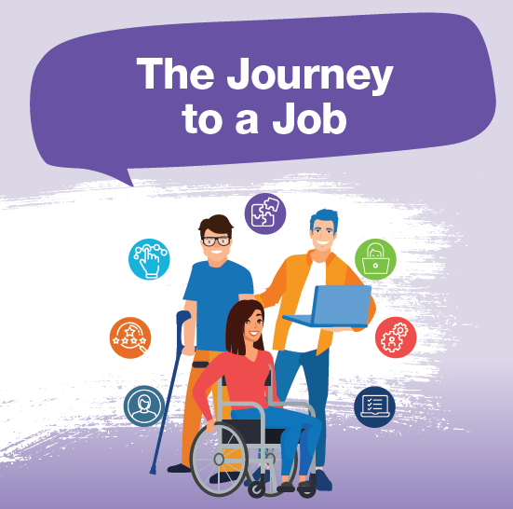
Customised Employment is a person-centred approach to employment supports and services. The goal of customised employment is to tailor a job to fit the skills, interests, strengths and support needs of a person with disability whilst meeting the needs of business.

Customised Employment Online Training

The Discovery Process

Getting to know me
Identify and meet with your paid and unpaid support networks. Get to know your interests, likes and dislikes. Start by visiting your home and immediate surrounding areas. Discover existing talents and skills.

Job Skills Analysis
Explore your wider community with your support worker to find existing skills and talents. Look at your existing activities and extended networks to find employment related strengths and skills that could be used at work. Consider other people to talk to and arrange meetings. For example your: sporting, school or community contacts.

Employment Pathways
Consider employment pathways that match your interests and skill set. Research all the different jobs that exist in those employment pathways. Consider what new work related skills are needed and how to develop them. For example: courses, self directed learning or work place social skills.

Workplace Information Collection
Gather details about what skills and requirements are needed in potential work places. Conduct informational interviews and find work sampling opportunities. Gain insight into different workplace cultures. Will you feel comfortable in these? Are there any skills or knowledge you need to develop further?

Job Planning
Take time to reflect and write down: what has worked well, what has been a challenge and what actions to take next. Do you have a clear career pathway in mind or do you need more information?
Where can you complete work experience opportunities? Are there tasks within potential jobs that may be challenging and require a Job Analysis Record?

Preparing to Work
Link with people who will help you prepare and find a job. Prepare a resume or online portfolio, practice job interviews and workplace social skills, organise work attire and getting to work. Begin contacting potential employers. Identify your ideal working conditions. For example: days, times and environment.

Review and Report
Use the Discovery document as a review and reporting tool. Share knowledge and information with your team. Consider: what has worked, what are the challenges and what needs to happen next to become employed? What Customised Employment pathway will suit you best? For Example Job Carving or Micro Enterprise?

Job Carving
Job carving involves negotiating a customised role that matches the interests, skills and abilities of the jobseeker with the needs of the employer.

Employer Engagement
Use existing resources or develop new ones to engage with potential employers or employment organisations.
Update resume.
Look for job opportunities with support team.
Consider any assistive technology such as communication devices, computer or laptop, mobile phone.

Role Negotiation
Negotiate the employment contract of a position.
Use a co-design approach with your support team and employer to establish a position description.
Ensure role negotiation occurs and necessary supports are in place prior to starting work.

On-the-job Support & Employer Assistance
Where required provision of one-to-one support for you as the employee, in collaboration with the employer.
Support might be required in areas such as: during induction, when learning job requirements or in establishing the processes and practices required for the job.
Get to know the people at work to build natural peer supports or other networks.

Ongoing Support
Provision of support for you, to manage any barriers that may put your job at risk.
Provide the right level of support for you. Plan to phase this out if this meets your ongoing needs.
DES providers can offer ongoing support for individuals who do not need one-to-one ongoing support.
Would you like to work for yourself?
A micro-enterprise is a small business with a start-up cost of less than $500 that can be owned and operated by a person with disability with support from the NDIS, family and community.
A micro-enterprise is best informed by a discovery process to ensure the work is suitable, sustainable and meaningful for the individual. Valued Lives Inc. have an online directory where any person with a disability who has their own micro-enterprise can advertise and promote their business free of charge.
Visit the website here: micro-enterprise.valuedlives.org.au
This project is a NDIS Information, Linkages and Capacity Building (ILC) initiative.

